

FACULTY OF TECHNOLOGY AND ENGINEERING
DEVANG PATEL INSTITUTE OF ADVANCE TECHNOLOGY AND RESEARCH
DEPARTMENT OF INFORMATION TECHNOLOGY

A.Y. 2026-27 [SEMESTER 3]

LAB MANUAL

CEUE203: Object Oriented Programming


Practical 13

Generics and repositories
Problem Statement:
1. Generic containers: use Box<T>, Pair<A,B>, and a generic first-element method without casts.
2. Bounded stats: calculate averages for arrays of different Number subclasses.
3. Generic stack: reuse a typed stack and handle an empty pop safely.
Expected Output: The sample programs demonstrate the required behavior; see the captured console output below.

Solution:

BoundedStats.java
public class BoundedStats {
public static <N extends Number> double average(N[] values) {
if (values.length == 0) throw new IllegalArgumentException("Values cannot be empty.");
double total = 0;
for (N value : values) total += value.doubleValue();
return total / values.length;
}
public static void main(String[] args) {
System.out.println(average(new Integer[]{2, 4, 6}));
System.out.println(average(new Double[]{1.5, 2.5}));
System.out.println(average(new Long[]{10L, 20L}));
}
}

GenericContainers.java
import java.util.List;
public class GenericContainers {
private record Pair<A, B>(A first, B second) { }
private static final class Box<T> {
private T value;
T get() { return value; }
void set(T value) { this.value = value; }
}
private static <T> T first(T[] values) {
if (values.length == 0) throw new IllegalArgumentException("Array is empty.");
return values[0];
}
public static void main(String[] args) {
Box<String> text = new Box<>();
text.set("Java");
Pair<Integer, String> pair = new Pair<>(7, "days");
System.out.println(text.get());
System.out.println(pair);
System.out.println("First item: " + first(new String[]{"type-safe", "code"}));
List<Integer> values = List.of(1, 2, 3);
System.out.println(values);
}
}

GenericStackDemo.java
import java.util.ArrayList;
import java.util.EmptyStackException;
import java.util.List;
public class GenericStackDemo {
private static final class Stack<T> {
private final List<T> items = new ArrayList<>();
void push(T item) { items.add(item); }
T pop() {
if (items.isEmpty()) throw new EmptyStackException();
return items.remove(items.size() - 1);
}
boolean isEmpty() { return items.isEmpty(); }
}
public static void main(String[] args) {
Stack<String> words = new Stack<>();
Stack<Integer> numbers = new Stack<>();
words.push("Java");
numbers.push(203);
System.out.println(words.pop());
System.out.println(numbers.pop());
System.out.println("Words stack empty: " + words.isEmpty());
}
}

MiniBank Project Work:

MiniBank progress ? Practical 13
Completed: Repository<T> provides reusable CRUD, reads keys from @Id fields with reflection, and supports safe varargs saveAll and bounded numeric averages.
Single project location: Java Programs\Minibank

Progressive source excerpts:

Minibank/src/main/java/minibank/repository/Repository.java
package minibank.repository;
import java.lang.reflect.Field;
import java.util.ArrayList;
import java.util.HashMap;
import java.util.Map;
import minibank.model.annotation.Id;
public final class Repository<T> {
private final Map<String, T> entities = new HashMap<>();
public synchronized T save(T entity) {
entities.put(readId(entity), entity);
return entity;
}
@SafeVarargs
public final synchronized void saveAll(T... items) {
for (T item : items) save(item);
}
public synchronized T findById(String id) { return entities.get(id); }
public synchronized ArrayList<T> findAll() { return new ArrayList<>(entities.values()); }
public synchronized boolean delete(String id) { return entities.remove(id) != null; }
public synchronized int count() { return entities.size(); }
private String readId(T entity) {
if (entity == null) throw new IllegalArgumentException("Entity cannot be null.");
for (Class<?> type = entity.getClass(); type != null; type = type.getSuperclass()) {
for (Field field : type.getDeclaredFields()) {
if (field.isAnnotationPresent(Id.class)) {
try {
field.setAccessible(true);
Object id = field.get(entity);
if (id == null || id.toString().isBlank()) {
throw new IllegalArgumentException("@Id field cannot be empty.");
}
return id.toString();
} catch (IllegalAccessException exception) {
throw new IllegalStateException("Unable to read the @Id field.", exception);
}
}
}
}
throw new IllegalArgumentException("Entity type has no field annotated with @Id.");
}
public static <N extends Number> double average(N[] values) {
if (values.length == 0) throw new IllegalArgumentException("Values cannot be empty.");
double sum = 0;
for (N value : values) sum += value.doubleValue();
return sum / values.length;
}
}

Output Screenshot:
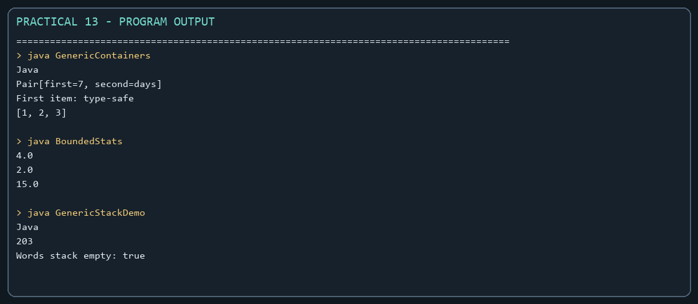
Captured from the compiled practical programs.

